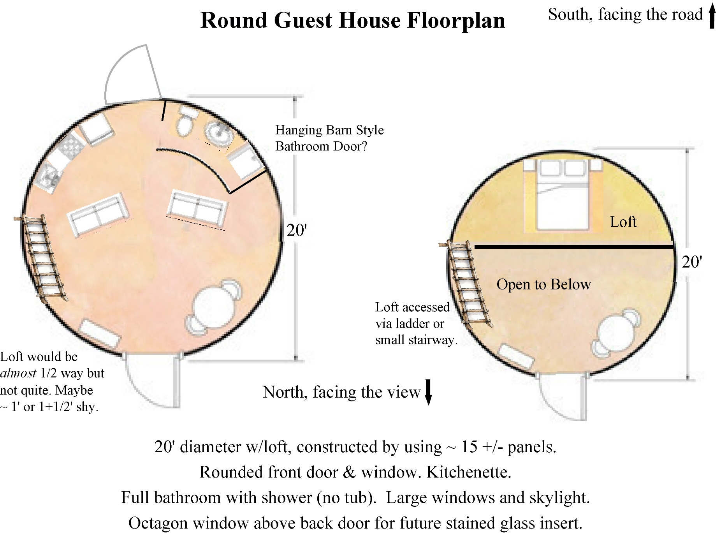
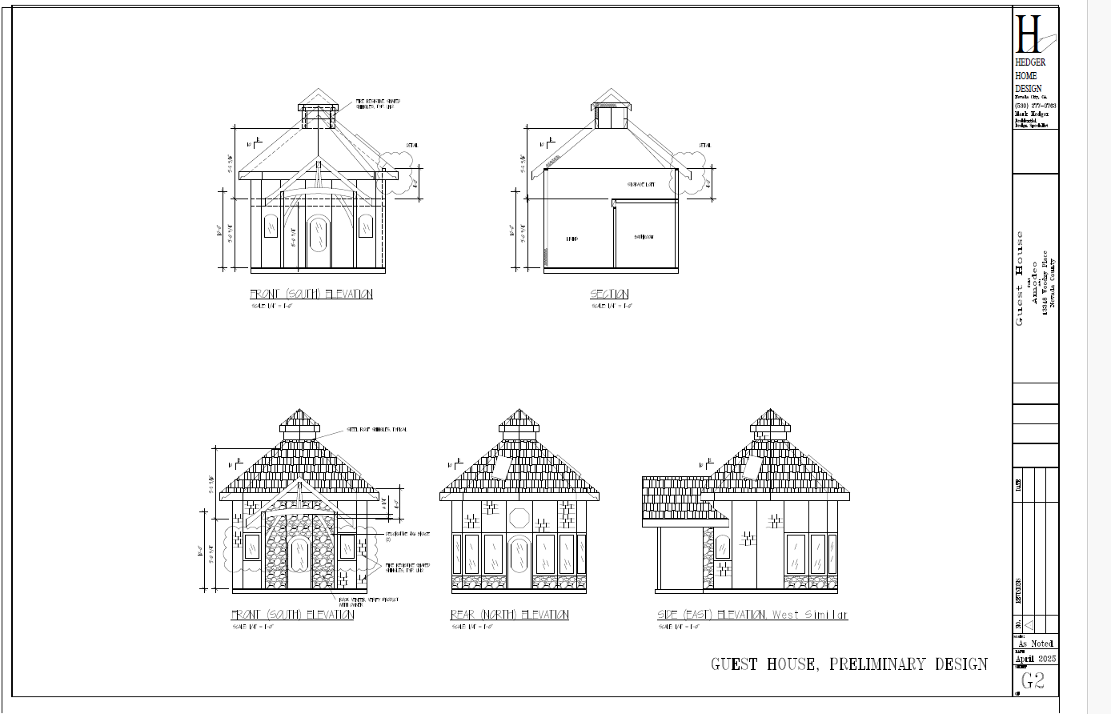
[Loft, kitchenette & bathroom will be against the south wall, not north. Building will be 20’ diameter, not 18.]
